**LOAD TESTING**

**Tester Name** : Rubel Hosain

**Load Test On Web-application**: <https://eticket.railway.gov.bd/login/en>

**Used Tool For Test** : JMeter

**Date**  : 22-01-2023

**This is actually load test summary report**

**Test Number 1:**

Frist time I was give user load 1000/ per 1 second. Here is image…

Given JMeter testing image:

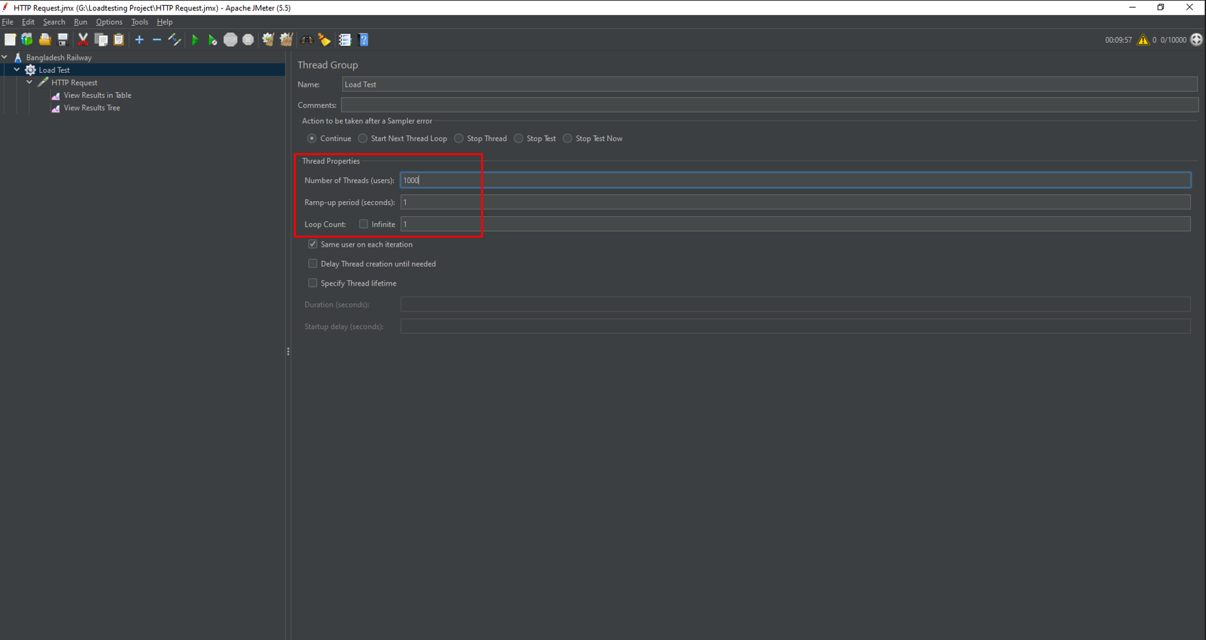

Load 1000/1s Login Page works smoothly. That is, if 1000 people come to the login page, they can login normally. The website may work properly at that time.

**Test Result: Passed**

**Report Table:**

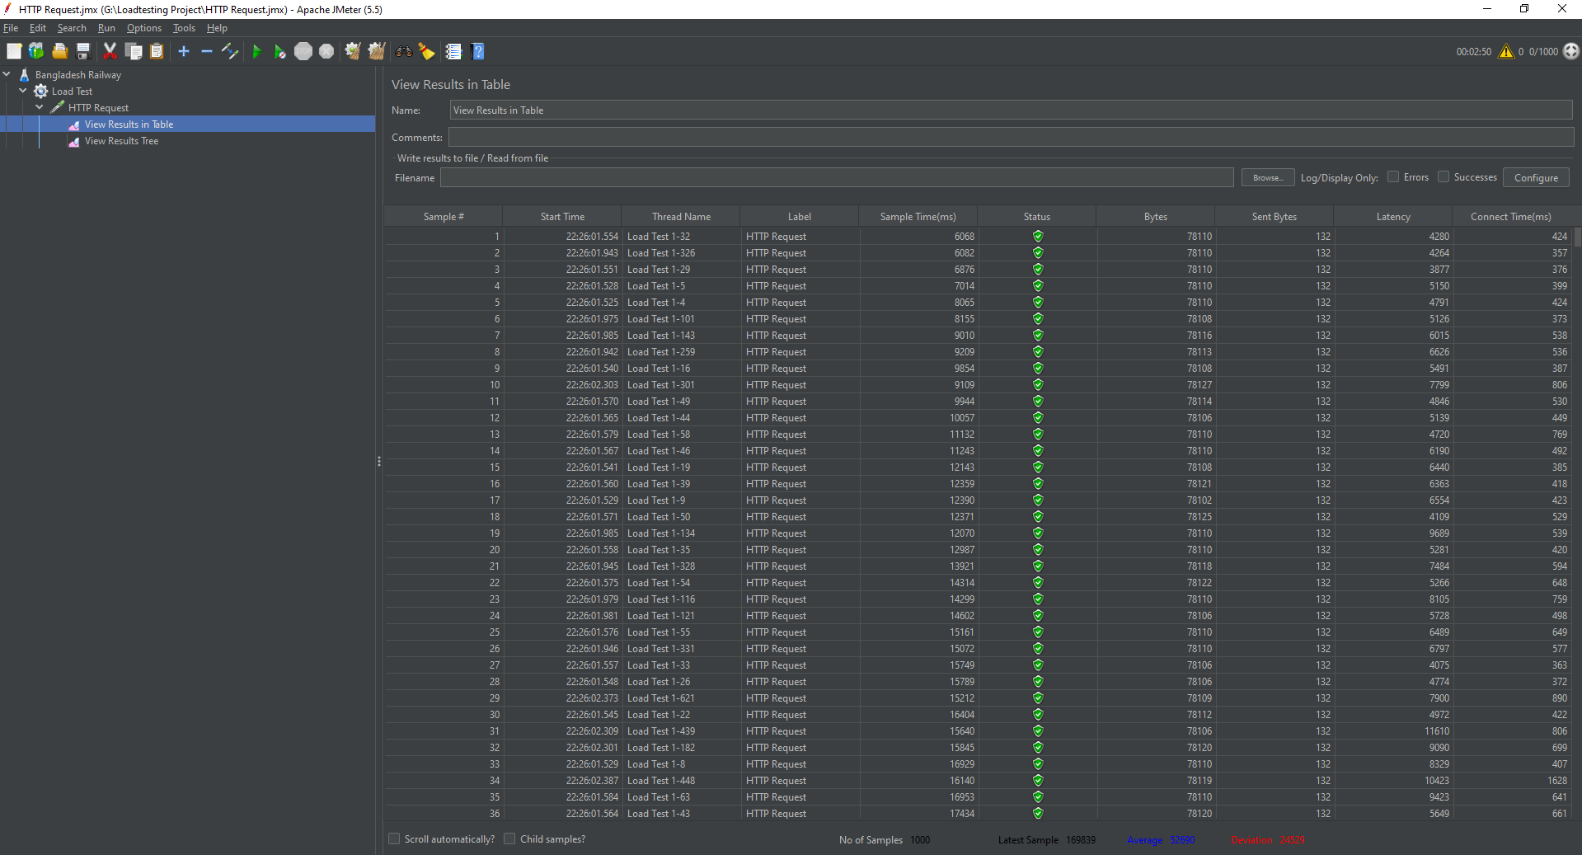

**Test Number 2:**

Second time I was give user load 10,000/ per 1 second. Here is image…

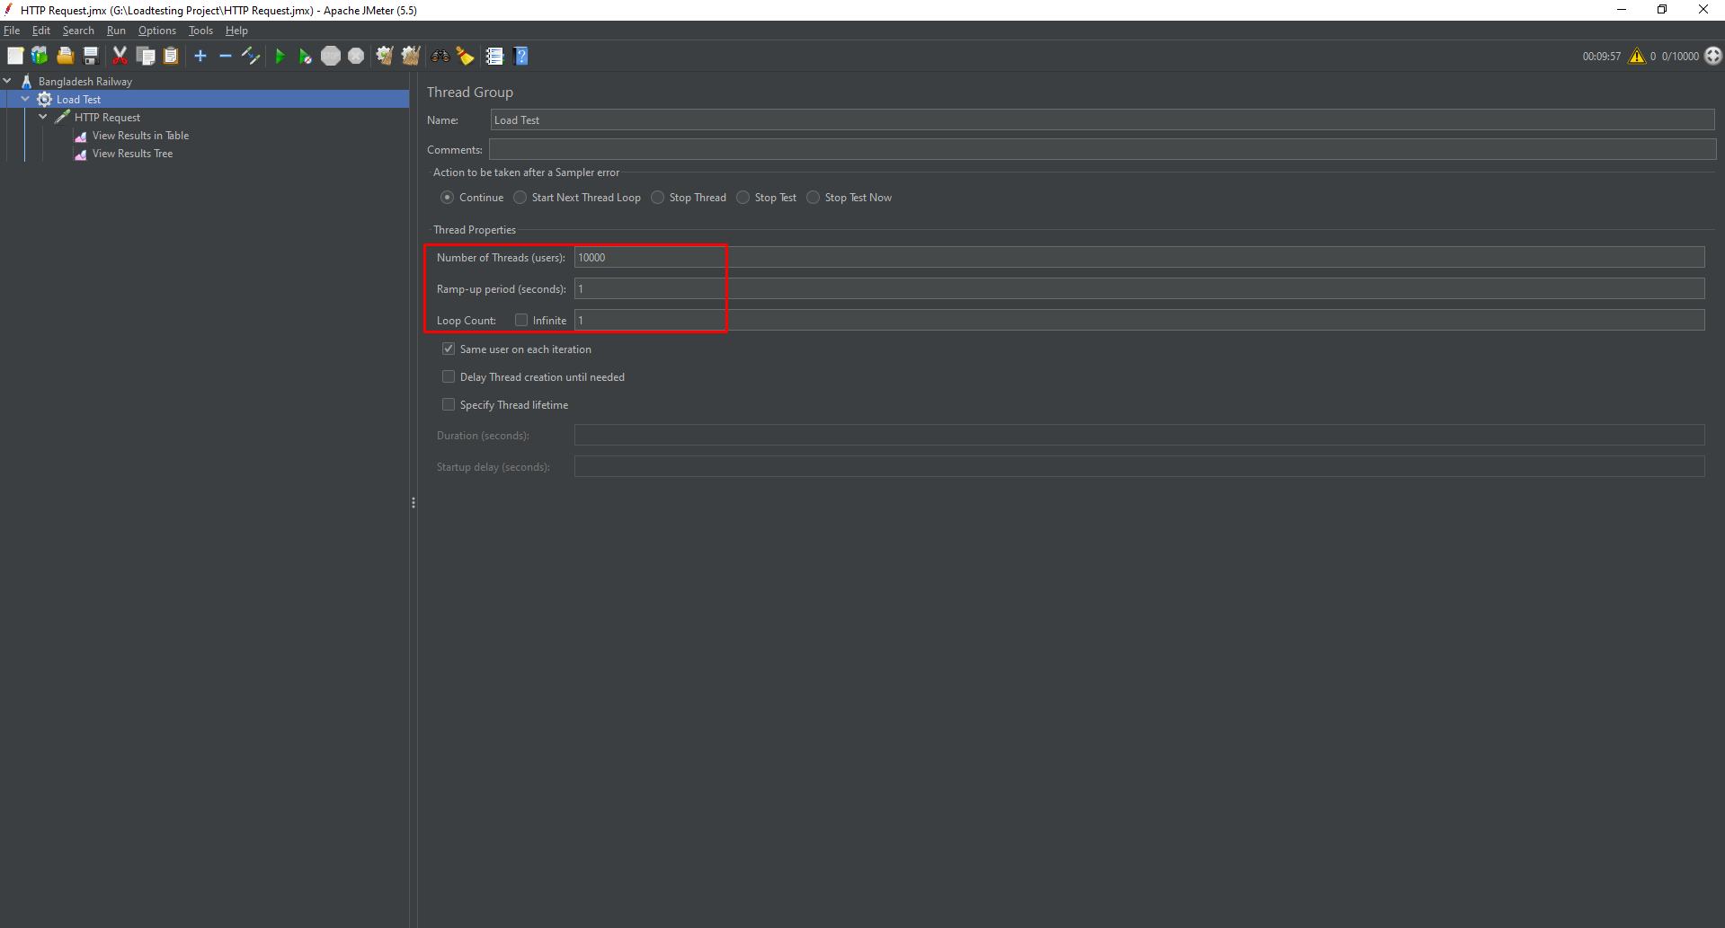

I increased the load to 10000/1s. As a result, the login page of the website could not work properly. Initially, the response was not available as per the request. But after some time the response was getting

**Test Result: Failed**

**Report Table:**

